1 INTRODUCTION

1.1 Overview

Web based Application project for a school is developed using wordpress software and it will be hosted using Godaddy

1.2 Purpose

The purpose of this website is to give an overall idea about the school and various teacher and students interaction purpose.

2 LITERATURE SURVEY

2.1 Existing problem

Wordpress - WordPress is a free and open-source content management system written in PHP and paired with a MySQL or MariaDB database. Features include a plugin architecture and a template system, referred to within WordPress as Themes

2.2 Proposed solution

Proposed solution is to design a website using wordpress

3 THEORITICAL ANALYSIS

3.1 Block diagram

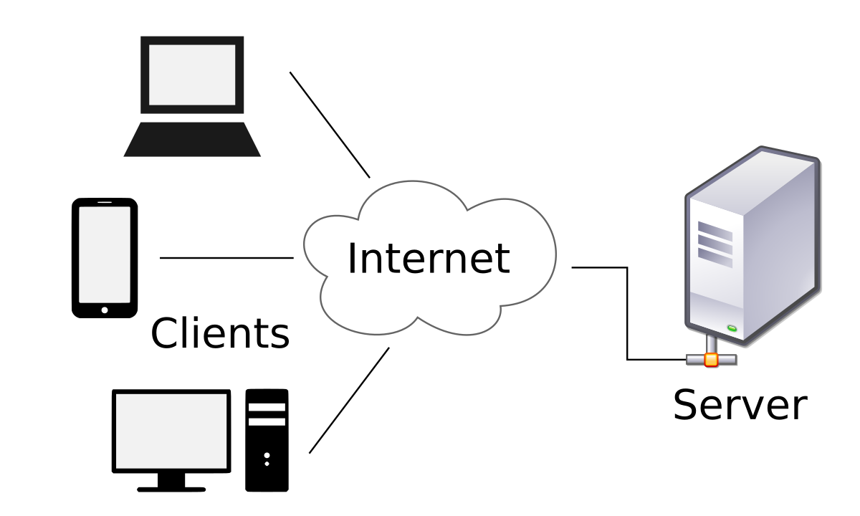

3.2 Hardware / Software designing

Hardware: Godaddy Web server

Software: Wordpress, xamp server

4 EXPERIMENTAL INVESTIGATIONS

* Wordpress is easier template tool for the development of web application.
* School website can be developed using wordpress and it has to be made live using Godaddy

5 FLOWCHART

Client Send Request to server

6 RESULT

